FINAL EXAM PORTFOLIO
AI in 5G and 6G Communications
and ORAN Networks
A Term Study Portfolio
MONICA JOYA
ITAI 4370 · Summer 2026
Houston City College
Instructor: Dr. Tawanda Chiyangwa
Term at a Glance
This portfolio documents my work in ITAI 4370, AI in 5G and 6G Communications and ORAN Networks, taught by Dr. Tawanda Chiyangwa at Houston City College during the Summer 2026 term. The course starts from the fundamentals of telecommunications, assumes no prior background in the field, and builds toward AI applications in next-generation networks, covering 5G and 6G architecture, Open RAN, network optimization, edge computing, security, and sustainable network design.
Each module below records the activities I completed and what I learned from them. The work is organized by module in the order it was completed during the term.
Term Timeline
Module | Milestone
01 | Assignment 01 and Lab 01: Signal Flow Analysis
02 | Assignment 02 and Lab 02: Free-Space Path Loss and Wireshark
03 | Assignment 03, Lab 03: Traffic Prediction, and Exercises 3.1 to 3.3
04 | Hands-On Exercise: 5G Network Architecture and AI Integration
05 | Open RAN and AI-Driven Networks
06 | Lab 04: Network Traffic Prediction
07 | Lab 05: IoT and Edge Computing with AI (in progress)
08 | Cybersecurity and AI in Telecommunications
09 | Sustainable AI and Green Communications
10 | Midterm Project: Network Simulation and Predictive Optimization
11 | Quiz: 6G and AI-Native Networks
13 | Assignment 04: Ethical AI and Future Trends
14 | Final Reflections

MODULE 01
Telecommunications Fundamentals
Module 01 covered the fundamentals of telecommunications, starting from no prior background. The main idea is that any communication system has three parts working in order: a transmitter, a channel, and a receiver, with noise affecting the signal along the way. We also covered analog versus digital signals, the four metrics for judging a link, the main types of communication, and how network topology affects reliability and cost.
For this module I did a written assignment on the basics and a two-part lab that followed a single message through a communication system.
Assignment 01: Telecommunications Fundamentals
The assignment was five written questions: what a telecom system is, the three parts of a communication system and the role of each, analog versus digital and how they are measured, the main types of communication, and how the star, mesh, ring, and bus topologies compare. Working through it, I learned the four metrics that judge a link, signal-to-noise ratio, bandwidth, latency, and throughput, and that the topologies make the most sense compared by how they fail: a bus or ring goes down if one point fails, a star depends on its central hub, and a mesh is the most reliable but the most expensive, so real networks combine them. I cited the slides and used the Forouzan textbook for the topology part.
Lab 01: Conceptual Communication System and Signal Flow Analysis
The lab had two parts. First I drew a communication system in draw.io, showing the path from source to modulator to channel to demodulator to receiver, with each block colored by function. Then I used Python to send a set of bits through the same system with BPSK, Binary Phase Shift Keying, and plotted the signal at each stage.
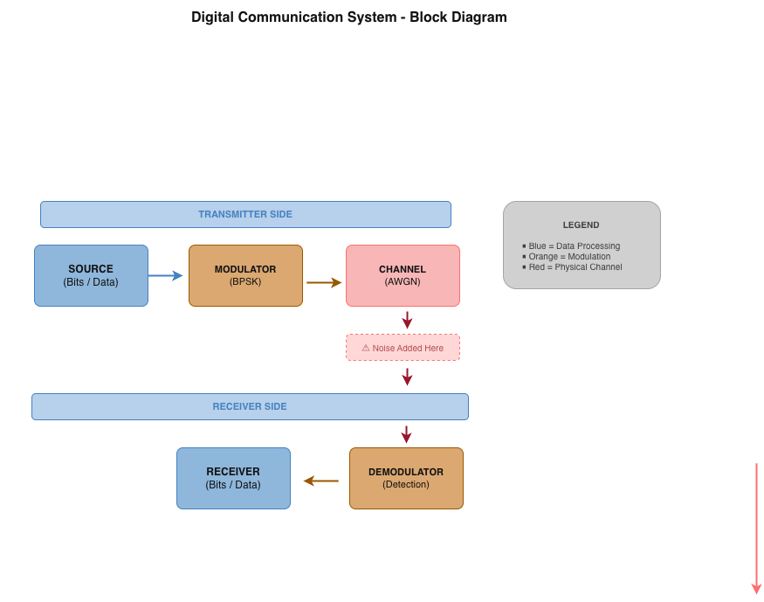
Figure 1. The communication system, drawn in draw.io.
From running it I learned how BPSK works: it sends a bit by setting the phase of a carrier wave, leaving a 1 as it is and flipping a 0 by 180 degrees. I used 20 random bits on a 5 Hz carrier, and the channel added noise at 10 dB. To recover the bits, the receiver multiplies the noisy wave by the same carrier and sums each bit period, reading positive as a 1 and negative as a 0. All 20 bits came back correct, since at 10 dB the signal stayed above the noise.
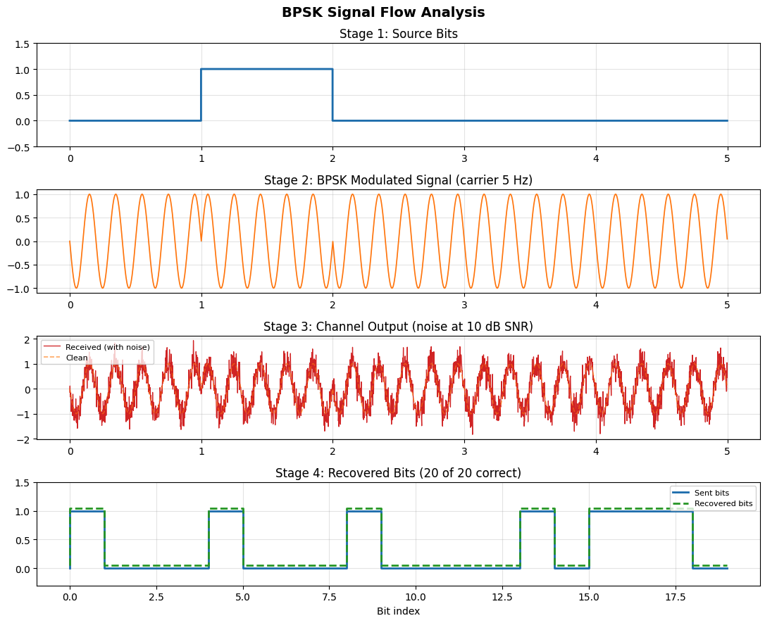
Figure 2. The signal at each stage of the BPSK flow.
MODULE 02
Network Architecture and Wireless Basics
Module 02 moved from a single signal to whole networks. It covered how networks are built and addressed, the TCP/IP model and the protocols that run on it, and the basics of wireless, including why a signal weakens as it travels. It also introduced the 5G core, comparing the older 4G design with the newer service-based 5G design.
I did a written assignment on the 5G core and a two-part lab, one part capturing and reading real network traffic, the other modeling how far a wireless signal can reach.
Assignment 02: The 5G Core Network
The assignment was five questions on the 5G core: the difference between the 4G core (the EPC) and the 5G core (the 5GC), why network slicing matters, what Multi-access Edge Computing is and how it cuts latency, how AI helps allocate resources, and what the Network Repository Function does. The slides and textbook did not cover this, so I used industry and standards sources and cited them in APA. What I learned here is how much the design changed. The 4G core is a fixed set of dedicated boxes, while the 5G core is small software services in the cloud that call each other only when needed, which is what lets it scale and slice. Slicing runs several tuned networks on one physical network, so 5G can serve very different needs, like factory robots and a crowd of sensors, at once. Edge computing cuts the distance data travels by putting cloud power near the user, and the Network Repository Function is the directory those services use to find each other.
Lab 02, Activity 1: Network Protocol Analysis with Wireshark
For the first activity I captured 2599 packets on my Wi-Fi during about a minute of normal browsing, then used the ip, tcp, and http filters to sort the traffic and read the headers for addresses, protocols, ports, and round trip time. This made the layers concrete: private and public IP addresses, TCP for reliable connections and UDP for fast traffic like QUIC, and temporary ports on my end talking to port 443 on the server. Almost everything went to port 443 and the http filter returned nothing, which shows that web traffic today is encrypted, over HTTPS and QUIC rather than plain HTTP. Round trip time is the gap between sending a segment and getting its acknowledgment, and Wireshark measured it directly, 94 microseconds in my capture.
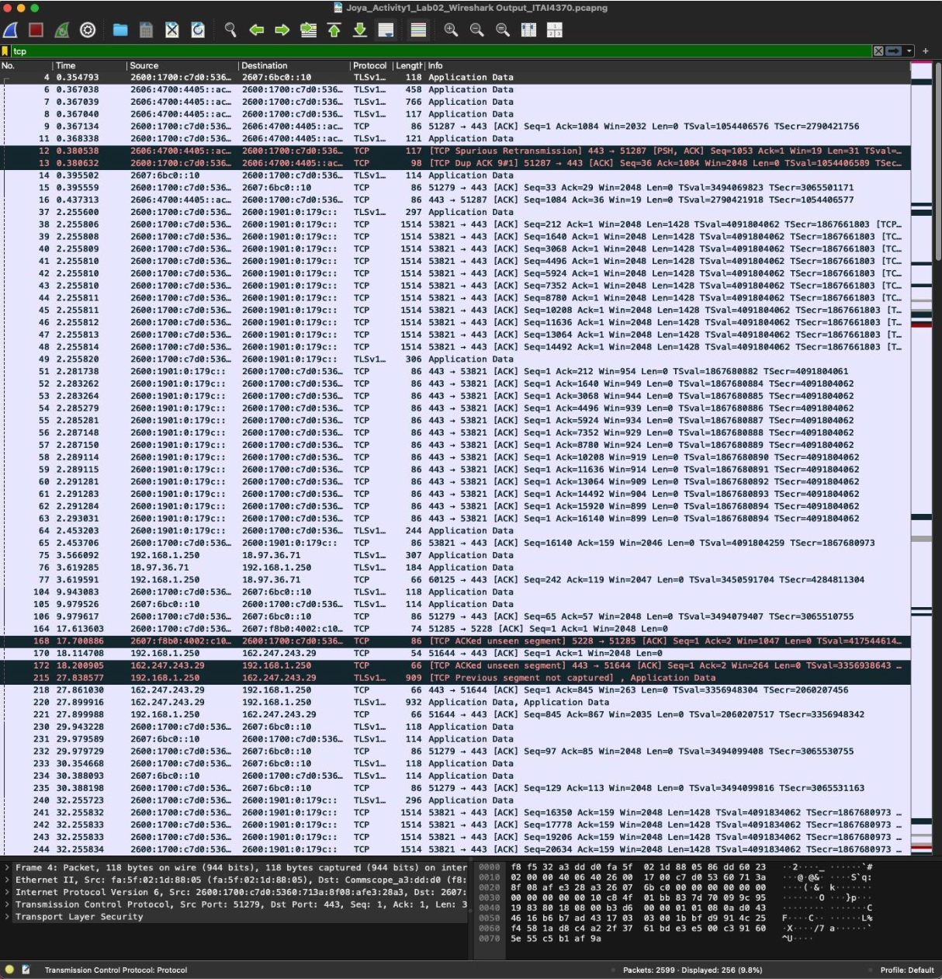
Figure 3. Live capture in Wireshark, filtered to show TCP traffic to port 443.
Lab 02, Activity 2: RF Propagation Modeling (Free-Space Path Loss)
The second activity modeled radio propagation in Python. Using the free-space path loss formula, I calculated the loss in decibels for a 2.4 GHz Wi-Fi signal at distances from 0.1 to 20 kilometers and plotted it. The curve climbs steadily, and from it I learned that path loss increases with both distance and frequency, so a signal weakens the farther it travels and the higher its frequency. That is why higher-frequency links like much of 5G reach shorter distances and need cell towers placed closer together.
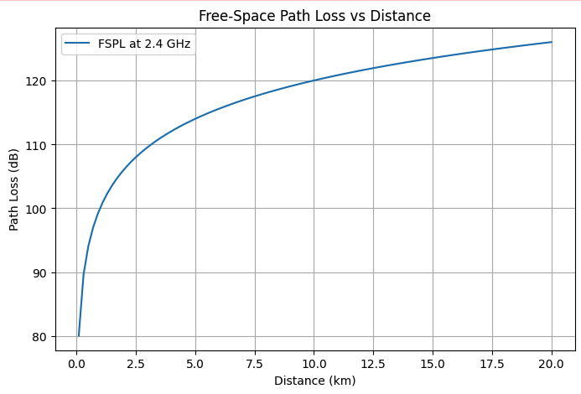
Figure 4. Free-space path loss for a 2.4 GHz signal from 0.1 to 20 km.
MODULE 03
AI and Machine Learning Fundamentals for Telecom
Module 03 introduced AI and machine learning for telecom, and it was where I wrote my first machine learning code. It covered how learning models help a network make faster decisions than fixed rules, mostly around the radio access network and Open RAN. This is where the course moved from how networks work to how AI improves them.
I did a written assignment on AI in Open RAN, a lab that predicted network traffic, and three short exercises on prediction, anomaly detection, and grouping users.

Assignment 03: AI and Machine Learning in Open RAN
The assignment was five written questions on how AI fits into Open RAN. The main points: AI lets the radio network get ahead of problems, forecasting a busy period and moving spectrum to a cell before it congests, or flagging a base station that is starting to fail before service drops. A Self-Organizing Network manages itself, with self-optimization adjusting settings like power and handovers, and self-healing letting nearby cells extend coverage when one goes down. The RAN Intelligent Controller works at two speeds: the Non-RT one, around a second or more, handles policy and model training, while the Near-RT one, about ten milliseconds to a second, makes live decisions like handovers and interference. This was newer material the slides did not cover deeply, so I built the answers from industry and standards sources and cited them in APA.
Lab 03: Network Traffic Prediction
This was my first machine learning model. Using the starter code, I built a Random Forest that predicts hourly network traffic from past data, on a synthetic dataset with realistic patterns: a daily rise and fall, quieter weekends, a slow yearly drift, and a bump during business hours. Most of the work was in the features. Lag features and rolling averages give the model the recent history it needs, and the traffic from one hour and twenty-four hours earlier was the most useful. I learned that this is supervised regression, where the model learns from labeled past data to predict a number, and that a Random Forest fits it because averaging many decision trees keeps the result steady on pattern-heavy data.
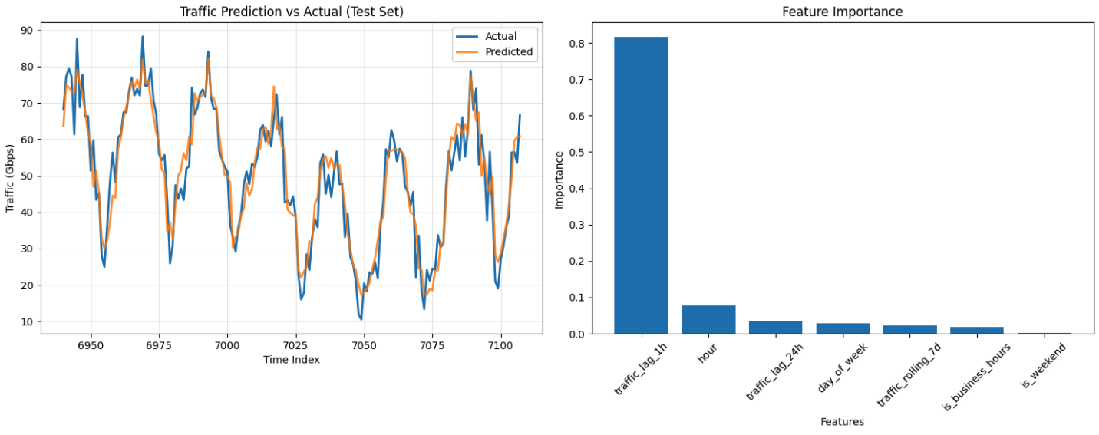
Figure 5. Random Forest traffic prediction against actual traffic, with feature importance.
Exercises 3.1 to 3.3: Prediction, Anomaly Detection, and Segmentation
Three short exercises extended the toolkit. 3.1 repeated traffic prediction with a Random Forest and reported error, R-squared, and feature importance. 3.2 was anomaly detection, comparing an Isolation Forest with DBSCAN on traffic that mixed normal flows with congestion and attack-like spikes, scored with precision, recall, and F1 rather than plain accuracy, since the rare events are the point and missing them is costly. 3.3 was customer segmentation, using K-means with PCA to group users by their data, calls, texts, and spending. Side by side, I learned the difference between the three: regression predicts a value, anomaly detection flags the unusual, and clustering groups similar records, and the last two work without labels, which fits telecom data since most of it is never labeled.

MODULE 04
5G Architecture and AI Integration
Module 04 covered 5G architecture and where AI fits in. The main idea is network slicing, running several tuned virtual networks on one shared physical network so it can serve very different needs at once. It tied this to the three standard service types and to sharing limited resources fairly between them.
The work was a hands-on Python lab that modeled 5G network slices and split resources between them with a simple priority-based algorithm.
Hands-On Lab: 5G Architecture Modeling with Python
I modeled the three 5G service types as slices, each with its own needs: URLLC for ultra-reliable low-latency control, eMBB for high-bandwidth mobile broadband, and mMTC for large numbers of low-power devices. I generated synthetic demand for each slice, then ran a proportional allocation that weighted each one by priority, URLLC highest and mMTC lowest, and normalized the weighted demand to a fixed pool of 500 units. One fix was needed first: the starter code recorded only one demand per slice instead of one per connection, so I moved that line inside the loop before running it. I learned that the normalizing step is the core of the algorithm, since it turns requests of different sizes into fair shares that always add up to the capacity available, which is how a real network gives the larger share to priority, latency-sensitive traffic while staying within its limits. This is the same lab referenced in the Module 03 assignment.
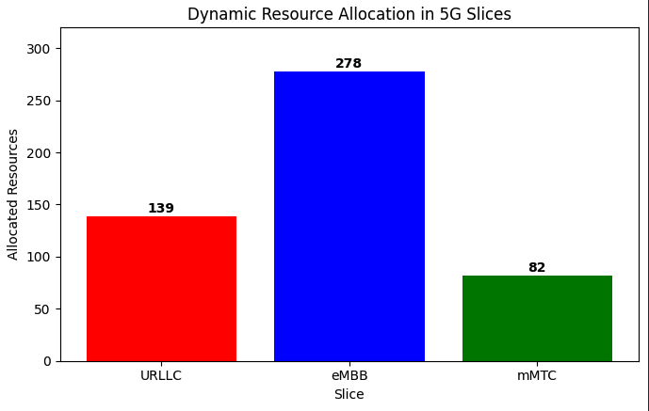
Figure 6. Allocated resources across the URLLC, eMBB, and mMTC slices.
MODULE 05
Open RAN and AI-Driven Networks
Module 05 covered Open RAN in depth, the shift from locked, single-vendor radio networks to open ones that different vendors can build together and that AI can steer. The readings paired the lecture with survey papers on mobile edge computing and the path from earlier open designs to Open RAN.
This was a reading module, so the work was going through the lecture and papers and pulling out how the architecture fits together, which set up the concepts used in the Module 03 assignment. Open RAN splits the radio network into named parts: the Radio Unit for the antenna signal, the Distributed Unit for real-time baseband, the Centralized Unit for non-real-time baseband, the RAN Intelligent Controller for optimization, and the Service Management and Orchestration layer that coordinates them. I learned that what makes it open is the standard interfaces between those parts, links named A1, E2, F1, E1, and O1, which break vendor lock-in and let an operator mix equipment from different vendors while AI reaches across the layers. That AI runs through the RIC and covers most of the stack, handling radio resource management, spectrum, energy efficiency, traffic prediction, and anomaly detection, while the Self-Organizing Network features handle configuration, optimization, healing, and protection.
MODULE 06
AI for Network Optimization and Management
Module 06 continued the traffic prediction work and compared several ways to forecast network load. Where Lab 03 used one Random Forest, this module put three different model families against the same data.
The work was a lab that built and compared three traffic prediction models: a classic statistical one, a linear one, and a neural network built for sequences.
Lab 04: Network Traffic Prediction with Time Series Analysis
I built three models on a full year of synthetic hourly traffic and measured how close each came to the real values: ARIMA, which uses statistical structure; Linear Regression, which is simple and fast; and an LSTM, a neural network that can learn longer patterns in a sequence. One result needed troubleshooting. The Linear Regression model scored almost perfectly, with error near zero, which is misleading. Its moving-average features in the starter code included the current hour, so each average already held the value the model was predicting, which is target leakage. I learned that a near-perfect score like that is a warning sign, not a good result, and that identifying the leakage mattered more than the number. I kept the starter code as written, changed only the one line the newer pandas version required (freq='H' to freq='h'), and documented the leakage rather than hiding it.
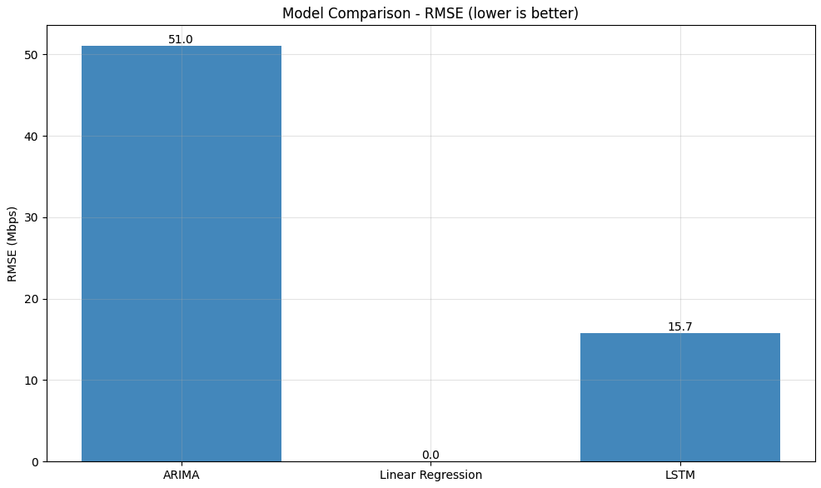
Figure 7. RMSE comparison of the ARIMA, Linear Regression, and LSTM models (lower is better).
MODULE 07
IoT and Edge Computing with AI
Module 07 covered moving AI from the cloud to the edge, meaning small field devices with limited memory and power. The main question was how to shrink a full-size model enough to run on such a device without losing much accuracy. I kept a build journal for this lab to record the setup problems and how I handled them.
The work was a lab that compressed one full model three ways for edge devices, along with a short build journal of the problems I ran into.
Lab 05: Edge Computing Simulation
I started with a full-size cloud model trained to classify device states from synthetic IoT sensor data, ten thousand samples with twenty features across three states, then shrank it three ways to run on a small edge device and compared what each method cost and saved. Part of the starter code was broken: the knowledge distillation section, where a small student model learns from the large teacher, was set up but never connected, so the student trained on its own and never used the teacher. I connected them so the student trains on the teacher's softened predictions, corrected the temperature so it is applied the standard way, and marked the change as mine. During setup I also hit TensorFlow install problems that broke the notebook tools, and I learned to test a fragile step on a tiny model before a full run to avoid wasting time. The full model reaches about 94 percent accuracy, and each smaller version trades a little accuracy for a much smaller size, which is the point of edge computing. I learned that on an easy dataset a small model already captures most of the signal, so distillation does not always come out ahead.
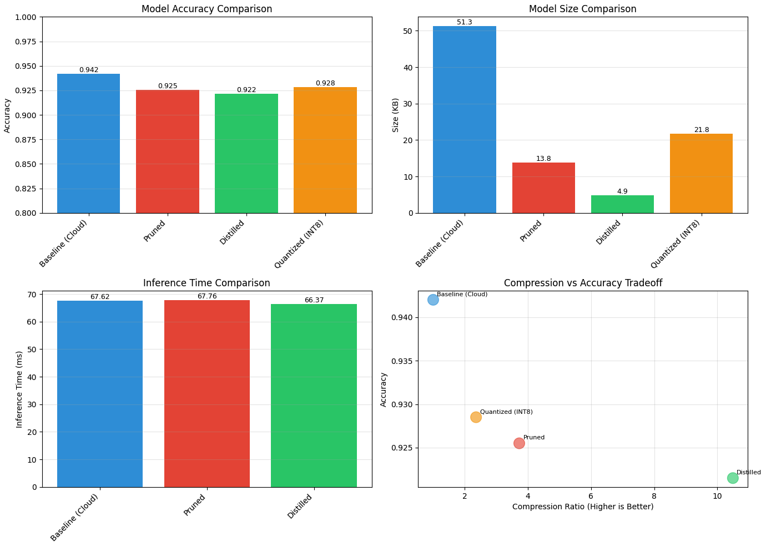
Figure 8. Accuracy and size for the full model and the three compressed versions.
MODULE 08
Cybersecurity and AI in Telecommunications
Module 08 covered how 5G and 6G widen the attack surface and how AI helps defend against it. It ran from classic network threats through the newer risks of cloud-based, sliced 5G cores, then into using machine learning to detect and respond to attacks, and finished on keeping that AI trustworthy and explainable.
This was a reading module built around the lecture, with the practical side shown through an intrusion detection walkthrough. What I learned is that 5G and 6G widen the attack surface: cloud-based cores, slicing, edge computing, and large device counts each add new entry points, on top of older weaknesses like downgrade attacks that force a fallback to weaker 4G. AI fits network defense because it can detect anomalies and attacks in traffic and automate the response, using supervised models for known attacks and unsupervised models for unknown ones. The AI itself also has to be defended, since adversarial machine learning can trick or poison a model, which is why explainable AI tools like LIME and SHAP matter, so an analyst can trust and check the alerts.

MODULE 09
Sustainable AI and Green Communications
Module 09 covered the energy cost of networks and how AI can reduce it. Base stations use most of the power, so the module focused on measuring energy use, designing greener networks, and using AI to manage power without hurting service quality.
This was a reading module on network energy, its metrics, and the AI methods that reduce it. Base stations are the largest draw, around sixty to eighty percent of the power, so most savings start there, and cooling adds a large share on top. Efficiency is tracked with metrics like PUE, which compares total facility energy to the energy the equipment actually uses, and lowering it saves real power. I learned that AI reduces energy in concrete ways: forecasting demand so cells can sleep when traffic is light, adjusting power dynamically, and optimizing cooling, with reinforcement learning treating it as a trade-off between saving energy and keeping service quality.
MODULE 10
Midterm Project: Network Simulation and Predictive Optimization
The midterm combined three ways of studying a network in one project: a discrete-event simulation, an agent-based model, and a machine learning predictor. Each part approached the same theme, how traffic moves through a network and how a network can manage its own load, from a different angle.
I put together a notebook with three parts, each built on the starter code and extended to measure and explain the result.
Part 1: Network Traffic Simulation with SimPy
Part 1 modeled three routers in a chain using SimPy, a discrete-event simulator. Packets are released over time and pass through each router in turn, and since each router handles one packet at a time, they queue when they arrive faster than a router can clear them. I extended the starter code to record each packet's timing so I could measure latency and throughput. The first packets got through near the ideal time and later ones waited longer, and I learned that this is what a discrete-event simulator shows well, turning the timing of events into latency numbers and a throughput figure for the chain.
Part 2: Agent-Based Network Modeling with Mesa
Part 2 modeled each router as its own agent using Mesa. Each router carries a load that rises and falls, and when one gets congested it moves its excess to neighbors that still have room. This part needed two fixes: the starter code used an older Mesa scheduler that was removed in the current version, so I moved it to the current approach, and the starter only printed a message when a router was overloaded without moving any load, so I connected that step so a congested router actually offloads to neighbors. Over thirty steps the busiest router rose above the congestion line several times and came back down each time as its load spread out, while the network average stayed steady. Nothing managed that centrally; the recovery came from each router acting on its own, which is the point of an agent-based model.

Part 3: Predictive Optimization with Machine Learning
Part 3 used scikit-learn to forecast traffic and then used the forecast to make routing decisions. I generated traffic, trained a regression model on its recent history, and tested it on data it had not seen. Then I ran it across two paths, predicting the load on each and sending new traffic to the quieter one, so congestion was avoided before it formed. Every feature was a past value, so there was no target leakage, the same issue I watched for in Lab 04. Forecasting the traffic was only half of it; what I learned is that the useful part is letting the forecast drive the routing, which is what self-optimizing means in practice.
Network Traffic Simulation with SimPy
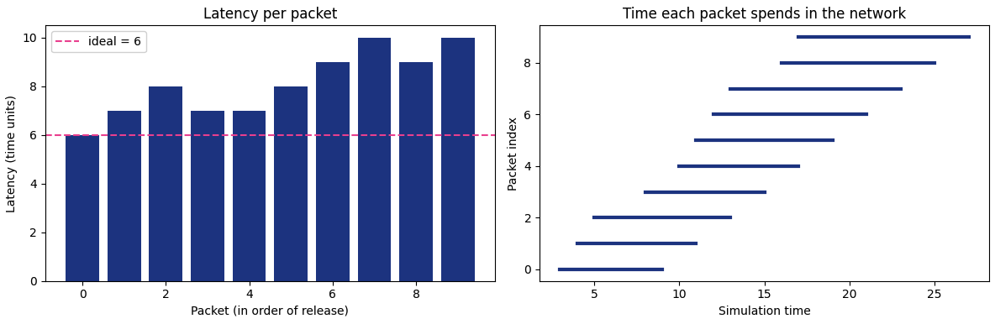
Agent-Based Network Modeling with Mesa
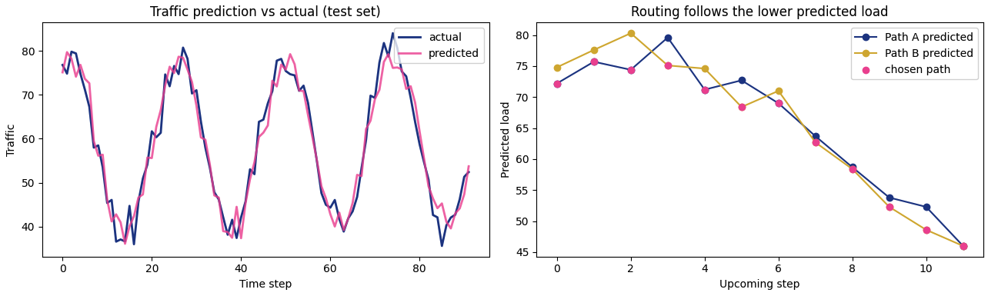
Predictive Optimization with Machine Learning
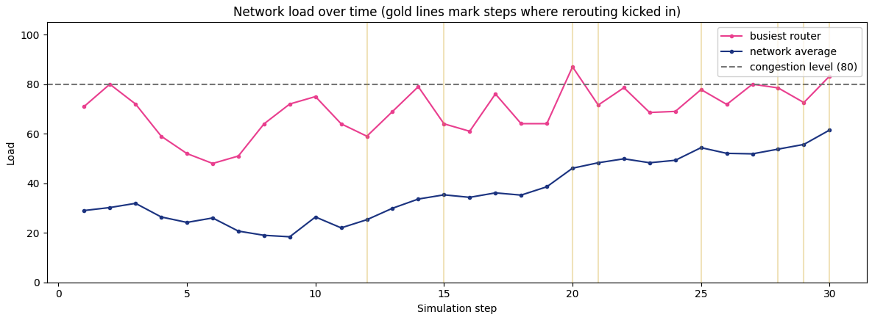
Figure 9. Sample output from the three midterm simulations.
MODULE 11
6G Vision and AI-Native Networks
Module 11 covered 6G and the idea of an AI-native network, where AI is built into every layer from the start rather than added later. It laid out 6G's targets and the technologies meant to reach them, and it was assessed with a quiz.
This module was assessed with a quiz on the 6G vision and AI-native network concepts. 6G aims well past 5G, with targets like terabit-per-second peak speeds, latency near a tenth of a millisecond, and much higher device density, which pushes it into terahertz spectrum. I learned that AI-native means the network is self-optimizing and self-healing by design and driven by intent, where an operator states a goal and the network configures itself to meet it. Federated learning fits here because devices can help train a shared model without sending their raw data off, which gives privacy and a better network at the same time.

MODULE 13
Ethical AI and Future Trends
Module 13 covered using AI responsibly rather than building it. It went over what ethical AI means, the principles behind it, the main frameworks and organizations shaping it, and how laws like the EU AI Act are starting to regulate it. This matters for telecom, where AI already steers networks that carry everyone's data.
The work was a written assignment on the concepts of ethical AI and applying them to real scenarios.
Assignment 04: Ethical AI and Future Trends
The assignment had two parts. The first was conceptual: what ethical AI means and why it matters, core principles like fairness, transparency, accountability, and privacy, the IEEE Ethically Aligned Design framework, algorithmic bias with a real example, the main international bodies in this area, and how the EU AI Act sorts systems by risk. The second part applied these to scenarios, like a hiring tool that favored male candidates. A few distinctions came out of it. Ethical AI is about respecting people and their rights, not just performance, and it matters because AI already makes decisions in hiring, lending, policing, and healthcare, where bias can cause harm at scale. I learned that transparency and explainability are not the same: transparency is being open about how a system works, while explainability is being able to say, in plain terms, why it made a specific decision. I also learned that the EU AI Act sets rules by risk level, from banned uses like social scoring, through tightly controlled high-risk uses like hiring and credit, down to low-risk tools with no obligations, so the more harm something could do, the stricter the rules. I grounded the answers in the module material and cited standards sources in APA.

MODULE 14
Final Reflections
Reflection 1: How My Understanding of Telecommunications Evolved
I started the course with no telecom background, and the early modules built it up step by step. Module 01 gave me the basic shape of a communication system, a transmitter, a channel, and a receiver with noise in between, and I traced a single message through it in code. From there it widened: whole networks and the TCP/IP model in Module 02, the service-based 5G core and slicing, then Open RAN and a radio network split into open parts that different vendors can build. By the middle of the term I could read a packet capture, model how far a signal travels, and explain how a 5G network shares one physical system across very different needs. The vocabulary that was unfamiliar in week one, terms like slice, path loss, RIC, and core, became something I could picture and explain.
Reflection 2: Applying AI to Telecommunications Problems
The second half of the course applied AI to real network problems, and my background in data and modeling helped here. I built my first machine learning model to predict traffic, then compared several model types on the same data and learned not to trust a score that looks too good, since I found a target leakage bug rather than just reporting the number. I modeled how a 5G network splits resources across slices, shrank a full model to run on a small edge device, and fixed a broken knowledge distillation step so it worked. Along the way I saw where AI defends networks, where it saves energy, and where it has to be kept ethical and explainable. The skills I improved most were practical machine learning, honest evaluation of results, and writing up a technical result in plain language. Going forward I want to work more with edge deployment and with the network and sensor data work that carries into digital energy roles.

